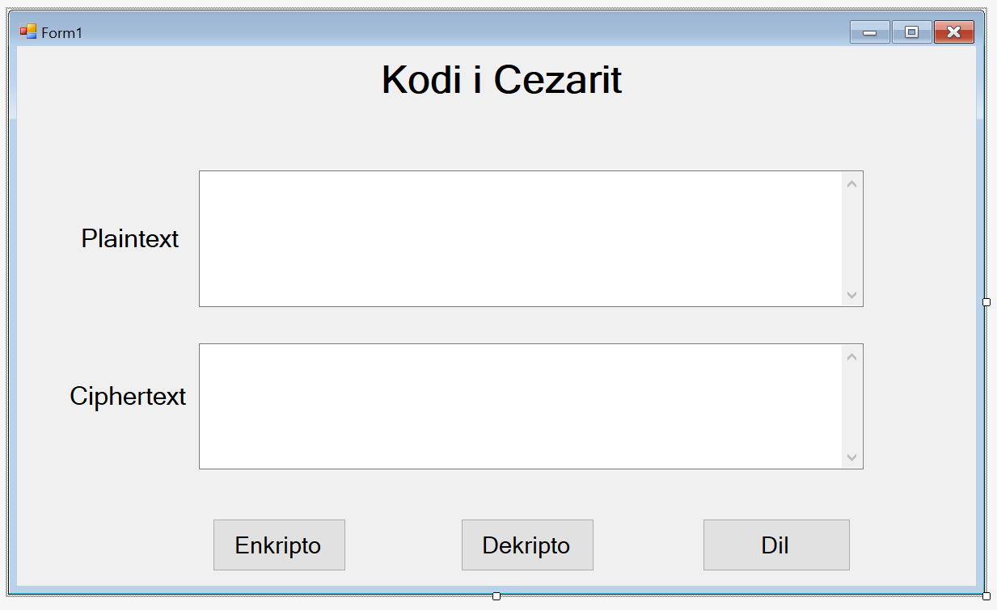Udhëzuesi për formimin e Kodit të Cezarit

Hapeni Visual studio -> File -> New Project -> Visual C# -> selekto Windows Form Application

Ju hapet forma si në vazhdim.

Label1: Text: **Plaintext**; Name: **label1**

Label2: Text: **Ciphertext**; Name: **label2**

Label3: Text: **Kodi i Cezarit**; Name: **label3**

TextBox1: Name: **txtOrigjinal**: ScrollBars: Vertical; Multiline: True

TextBox2: Name: **txtCipherText:** ScrollBars: Vertical; Multiline: True

Button1: Text: Enkripto; Name: btnEnkripto

Button2: Text: Dekripto; Name: btnDekripto

Button3: Text: Dil; Name: btnDil

Shtojmë dy librari:

using System.IO;

using System.Security.Cryptography;

Brenda public partial class, definojme variable celesi si:

static string celesi;

namespace SiguriaRrjetave

{

public partial class frmEncDec : Form

{

public frmEncDec()

{

InitializeComponent();

}

static string celesi;

private void btnEnkripto_Click(object sender, EventArgs e)

{

txtCipherText.Text = ekripto_cesar(txtOrigjinal.Text, 4);

}

private void btnDekripto_Click(object sender, EventArgs e)

{

txtCipherText.Text = dekripto_cesar(txtOrigjinal.Text, 4);

}

private void btnDil_Click(object sender, EventArgs e)

{

Close();

}

public static string ekripto_cesar(string teksti, int zhvendosja)

{

StringBuilder sb = new StringBuilder();

foreach (char shkronja in teksti.ToLower())

{

int vlera_enk = 0;

if (shkronja == ' ')

{

vlera_enk = ' ';

}

else

{

vlera_enk = (((shkronja - 'a') + zhvendosja) % 26) + 'a';

}

sb.Append((char)vlera_enk);

}

return sb.ToString();

}

public static string dekripto_cesar(string teksti, int zhvendosja)

{

StringBuilder sb = new StringBuilder();

foreach (char shkronja in teksti.ToLower())

{

int vlera_enk = 0;

if (shkronja == ' ')

{

vlera_enk = ' ';

}

else

{

vlera_enk = (((shkronja - 'a') - zhvendosja) % 26) + 'a';

}

sb.Append((char)vlera_enk);

}

return sb.ToString();

}

private void txtOrigjinal_TextChanged(object sender, EventArgs e)

{

}

private void txtCipherText_TextChanged(object sender, EventArgs e)

{

}

}

}